FOLKLORE & MYTHOLOGY
FALL 2014
(All courses taught in English unless noted otherwise)
A&S 100-001 VAMPIRES: EVOLUTION OF
A SEXY MONSTER
TR 2:00-3:15 Jeanmarie Rouhier-Willoughby
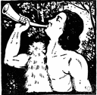
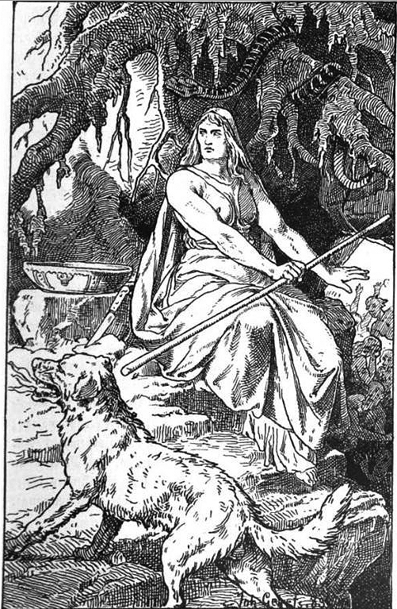
GER 103-001 FAIRY TALES IN
EUROPEAN CONTEXT
MW 12:00-12:50 Lecture + 1 recitation hour Linda K Worley
-UKCore Inquiry: Humanities-

CLA 135-001 GREEK & ROMAN MYTHOLOGY
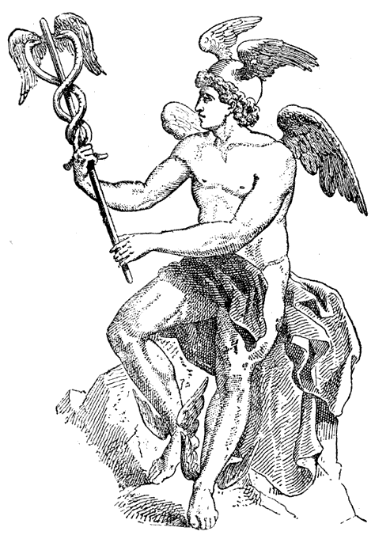
TR 11:00-11:50:00 + 1 on-line hour Paolo Visona
-UKCore Inquiry: Humanities-
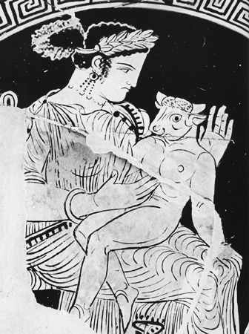
CLA 135-002 GREEK & ROMAN MYTHOLOGY
MW10:-10:50 1 on-line hour Valerio Caldesi Valeri
-UKCore Inquiry: Humanities-

FR 263-001 AFRICAN & CARIBBEAN LITERATURE
& CULTURE: SEX GENDER & VIOLENCE IN
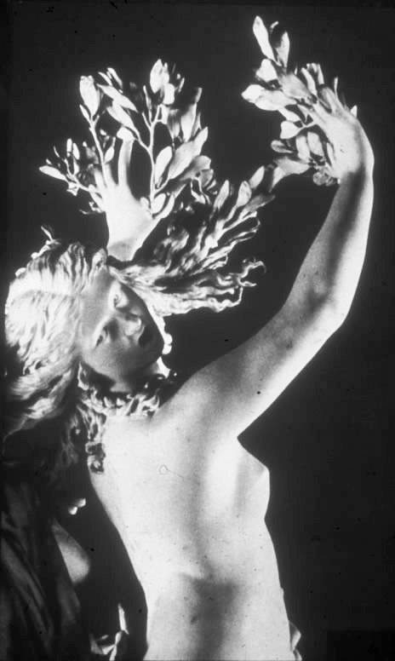
ORAL TRADITION & STORYTELLING
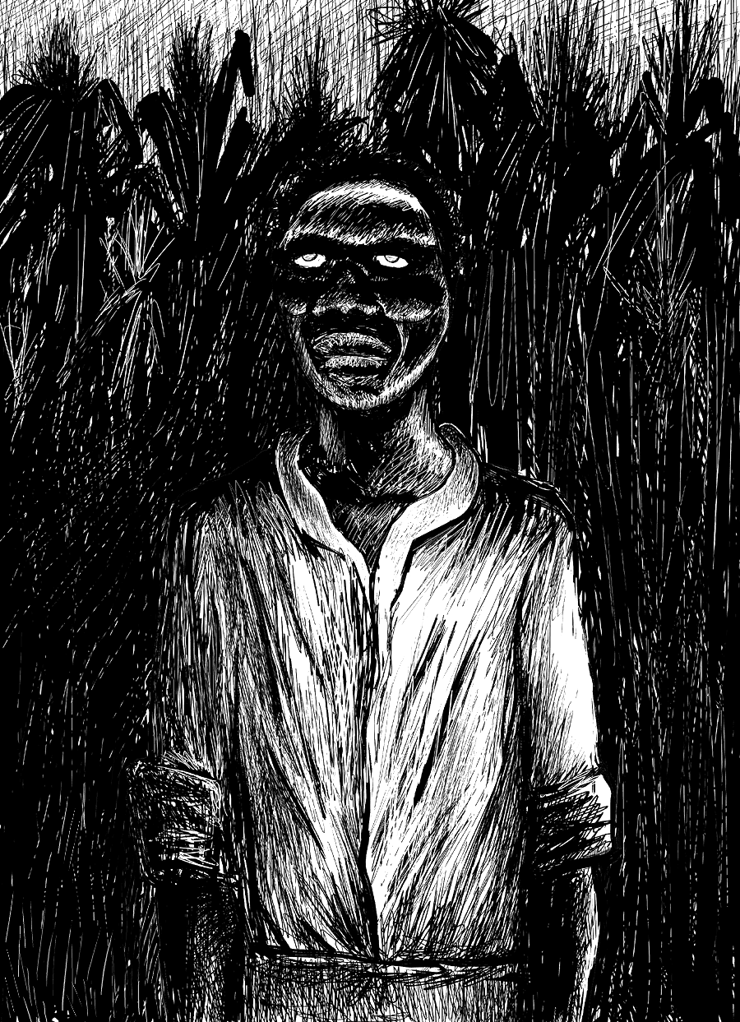
MWF 12:00-12:50 Jacqueline Couti

CLA 331-001 GENDER & SEXUALITY IN ANTIQUITY
TR 2:00-3:15 James A Francis
-Graduation Writing Rerquirement-

CLA 462G-001 STUDIES IN CLASSICAL LITERATURE
JUSTICE IN GREEK TRAGEDY
TR 11:00-12:15 James A Francis

GER 416G-001 STUDIES IN GENRE: FAIRY TALES
(taught in German)
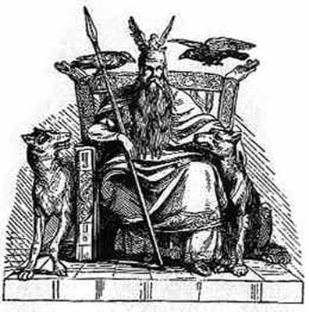
MW 2:00-3:15:00 Linda K Worley
